20xx
WireCAD Style Guide and Engineering Standards

Design Guide

Contents
Introduction 6
Consider your audience 6
File formats 6
Drawings 6
Reports 6
Images 6
Naming Conventions 6
The Apostrophe 6
Projects 6
Drawings 6
Manufacturer Names 7
Equipment Model Names 7
Port Names 7
Signal Types 8
Connectors 8
Cable Types 9
Racks 9
Drawing Conventions 10
Title-blocks and Page Borders 10
Printed Text Height 10
Functional Block Appearance 11
Terminal Block Appearance 12
Fiber Splices (barrels) 12
Butt Splices 12
Single Terminal Points 12
Jack Appearance 13
Spares Cable Connections 13
On/Off Sheet Pointers (Feathers) 13
Numbering Conventions 14
System Identification and Location 14
Cables 14
Report Content 15
Cable Run Sheets 15
Cable Labels 15
Deliverables 16
Required Drawings 16
Front Page Drawing 16
Fibre Infrastructure Drawing 16
Audio Interconnect Drawing 16
Intercom Interconnect Drawing 16
Distribution Interconnect Drawing 16
Optional Drawings 16
Specialty Equipment Drawing 16
Rack Layouts 17
Required Reports 17

Introduction
The purpose of this style guide is not to restrict but rather to unify our approach to system design and documentation. It is a work in progress and is meant to be a quick reference. Please try not to deviate from these standards. If you have a question on how to present a design please feel free to contact the Author Name Goes Here.

Consider your audience
YOUR COMPANY NAME GOES HERE documents are viewed by many different audiences. We recognize that it is difficult to present the design in a way that satisfies all viewers of the document. Consider that the viewer may be engineering management, installers or maintenance technicians. See the examples further in this document for the standardized approach. If you cannot convey your idea using one of the standardized approaches please contact Author Name Goes Here for help.

File formats
Please use the following formats when providing design documentation

Drawings
Drawings may be delivered in DWG or PDF formats.

Reports
All reports are to be delivered in PDF format.

Images
All images are to be delivered in PNG format.

Naming Conventions

The Apostrophe
Do not use the ( ‘ ) apostrophe anywhere in any field. It is the SQL server escape character and will damage queries to the database.

Project Names
YOUR COMPANY NAME GOES HERE shall create one project per ???. The project name shall be comprised of: YOUR RULES GO HERE.
Under no circumstances shall you use the word NEW in your project name like:
UNLV NEW AUDITORIUM. This project will be in use for years and the location will not be NEW anymore. More appropriate would be: UNLV AUDITORIUM 2019.
Correct:
MONTREAL 1000 RENE-LEVEQUE
Incorrect:
1000 rene-leveque

Drawings
Drawing names shall follow the existing YOUR COMPANY NAME GOES HERE sequential number format. This number sequence is controlled by the CAD department. If you need a new drawing please send a request to your CAD department for a new drawing. Please let them know the path that you would like the drawing to reside in.

Manufacturer Names
Manufacturer names and ManufacturerIDs (key fields in the WireCAD database) shall not vary from the public company name. Do not abbreviate the name in any way with the exception of removing special characters and punctuation. All Manufacturer name shall be entered in upper case.
Correct:
BOBS BOXES
Incorrect:
Bob’s Boxes

Equipment Model Names
Equipment manufacturers sometimes employ complex part numbering schemes to describe specific equipment options and finishes. It is important to convey the proper information or to be counted in the Bill of Materials (BOM), use specific part numbers or names. Use all caps. If you are unsure of the exact model that will be used in the final design you may use a generic part number/name.
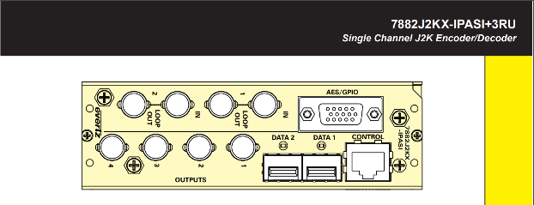
Correct:
    - 7882J2KX-IPASI+3RU

Incorrect:
    - 7882j2kx-ipasi+3ru
    - J2K Encoder/Decoder (this should go in the Description field)

Port Names
The port names shall match the silk screened port name on the device. Use ALL CAPS.
Correct:
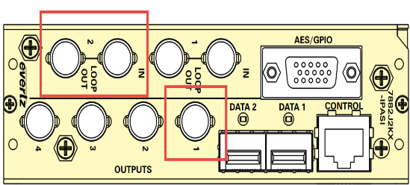
    - OUTPUTS-01
    - IN-02 (display port as loop)
Incorrect:
  - OUTPUT-01 (does not match panel label)
  - In-02 (not all caps)

Signal Types
Signal Types shall be ALL CAPS and descriptive of the signal carried, but in no event shall a signal type name exceed 8 characters. Set the default cable manufacturer, and cable type to an appropriate cable for the signal type. Do not confuse signal type with connector types and vice-versa; there are signal types that have matching connector types. For example: HDMI describes a signal type and a connector type. A signal type describes the signal carried, associates a default cable type, and defines the cable number prefix.
Correct:
AES ID3
HD SDI
Incorrect:
aes

Connectors
All connector types shall display connector gender and shall be upper case. In the case that a connection does not have a gender as in solder terminals, punch-down, or insulation displacement connections - no gender is required.
REMEMBER: When entering connector gender, that WireCAD requires the CABLE END not the chassis side gender.
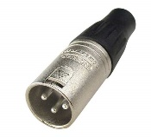
Correct:
Description Connector Name
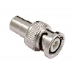
3 pin male XLR MXLR3
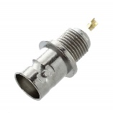
Male BNC MBNC
Female BNC FBNC
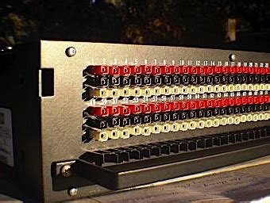
Punch Down PD
Incorrect:
3 pin male XLR MALE XLR 3 Pin, mxlr, or x
Male BNC BNC, bnc, mbnc, or b
Female BNC FEMALEBNC, fbnc, or b

Cable Types
Cable Types shall bear the exact manufacturer part number. Place any descriptive text in the description that will aid the reader to understand the function and color of the cable type.
Bulk Cable – Name field.
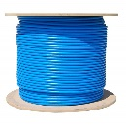
Correct:
- 1505A
Incorrect:
- 1505a
Premade or “off the shelf” cables do the following in the Name field:
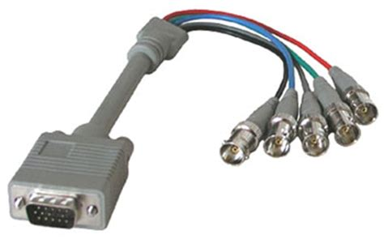
Correct:
- PREMADE HDMI-HDMI 1m
- PREMADE ETHERNET CROSSOVER 2m
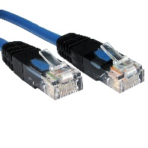
- PREMADE HDMI-RGBHV 3m
- OTS HDMI-HDMI 1m
Incorrect:
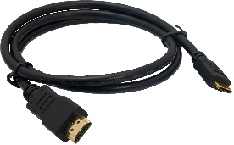
    - PREMADE HDMI-HDMI (missing length)
    - PREMADE ETHERNET Crossover 2m (not all caps)
    - HDMI-5BNC 3m (no indication that this is a premade cable )

Racks
Assigning racks a SysName in WireCAD requires that you align the SysName with the Location.
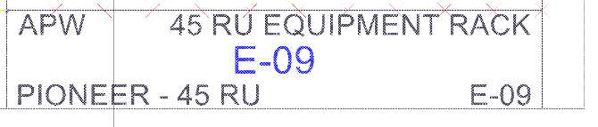
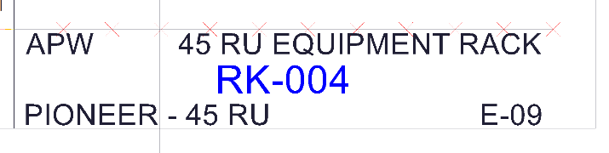
For example: let’s assume we are assigning a SysName to a rack named E-09 and that the next number in the racks sequence is RK-23. We would want to be sure that when WireCAD presents RK-23 as the SysName for that assignment we change it to match the location.
WRONG - CONFUSES READER
RIGHT SYSNAME IS LOCATION
Correct: Incorrect:

Drawing Conventions
The following drawing conventions are not presented to limit or inhibit, but rather to formalize and unify.

Title-blocks and Page Borders
Use the YOUR TEMPLATE DRAWING NAME GOES here in the WireCAD New Drawing Wizard.

Printed Text Height
Text output shall be XXXXX DU and shall be consistent across all drawings.

Functional Block Appearance
Functional block should look like this:
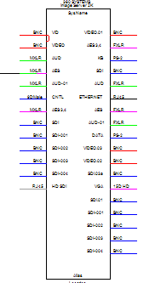
BodyColor:ByLayer
BodyWidth: 500
PinSpacing: 100
PinWidth:200
PinColor: By Signal Type
Vertical Padding: 0
Textheight: 25
Stock Shape: 1

Functional blocks that do not display all of their IO should look like this:
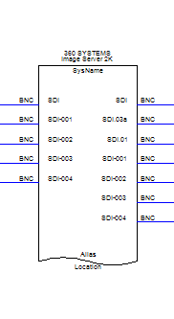
BodyColor:ByLayer
BodyWidth: 500
PinSpacing: 100
PinWidth:200
PinColor: By Signal Type
Vertical Padding: 0
Textheight: 25
Stock Shape: 3

Terminal Block Appearance

Fiber Splices (barrels)
Use XXX_SD.dwg
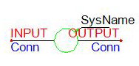

Butt Splices
Use ICON_SD.dwg
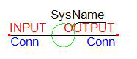

Single Terminal Points
Use WC3JBox_loc_xx.dwg. This terminal displays the location as well as SysName and Port info. Use to display any input or output port in a compact inline portable way.
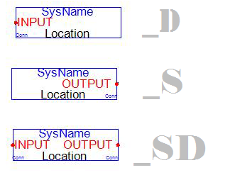

Jack Appearance
Full Normal Jacks
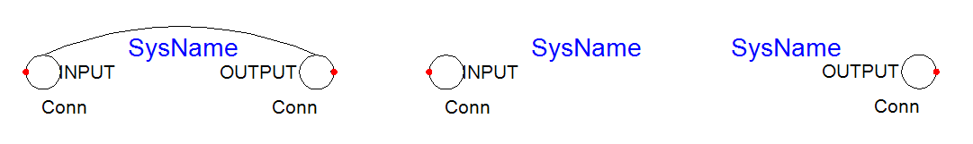

Spares Cable Connections
MORE

On/Off Sheet Pointers (Feathers)
Use the WC3_Pointer_v1_x.dwg and WC3_Pointer_FLIPPED_x.dwg.
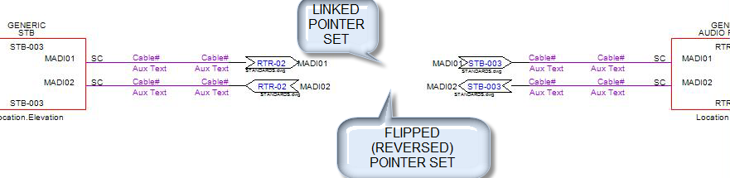

Numbering Conventions

System Identification and Location
System Name shall follow this format: XXX-###
Where XXX = the EquipmentType and ### represents a numeric sequence.
Locations shall follow the format: Campus.Building.Floor.Room.Rack.Elevation-slot

Cables
Cable numbers shall follow this format: XXX-#######
Where XXX is the Cable Number Prefix from the Project Signal Types databae. For example assume we are assigning cable with a signal type of VID and the Cable Number Prefix of V. The cable number for the first cable would be: V-000001

Report Content

Cable Run Sheets
Cable run sheets shall display cable type, source and destination system ID, port names, connectors, and locations, as well as cable type. Use Runsheet 11x17.repx or one of its variants.

Cable Labels
Cable labels shall be identical on both ends of the cable and shall display source and destination port information in the form S:SRCSSYS>SRCPIN for the source system and port and D:DESTSYS>DESTPIN for the destination system and port. For small cables use: XXXXXX.repx in either the 1UP or 3Up configurations.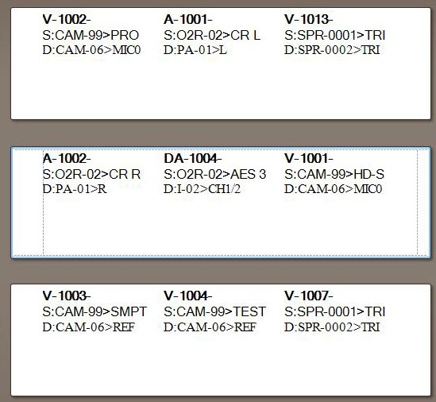

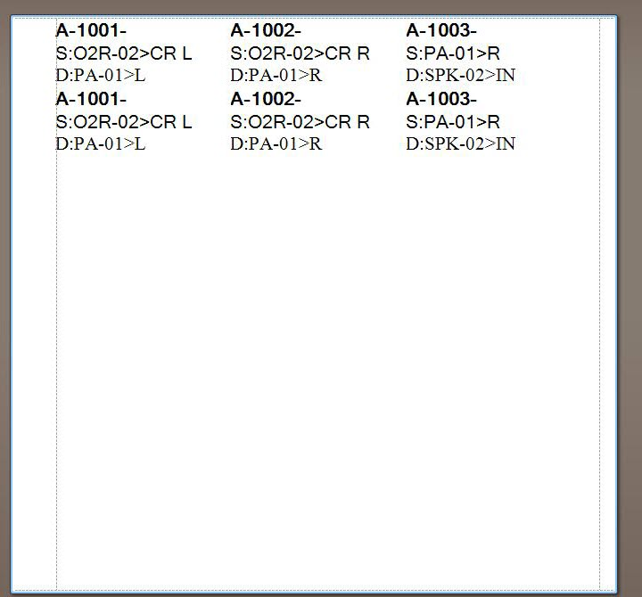
For larger cables use: XXXXXXX.repx

Deliverables

Required Drawings
The following drawings shall be included in all project packages.

Front Page Drawing
This drawing is meant to convey and overview of the interconnection of the project/venue.

Fibre Infrastructure Drawing
Contains all EO/OE terminal equipment and splicing information with pointers to and from other drawings in the set.

Audio Interconnect Drawing
Contains stage boxes, connections to OB routers and may point through the fibre infrastructure drawing.

Intercom Interconnect Drawing
Contains intercom interconnect and tally information.

Distribution Interconnect Drawing
Contains RHB interconnect.

Optional Drawings
If the venue size warrants, include the following drawings.

Specialty Equipment Drawing
Contains specialty cameras, operator positions and RF equipment details points through fibre infrastructure to and from the Front Page drawing.

Rack Layouts
Rack elevations for key locations.

Required Reports
Cable Runsheet
Cable Labels (Define quantity here)
Bill of Materials (BOM)

Drawing Layout and Appearance
It is important to YOUR COMPANY NAME GOES HERE that our drawing sets are the 3 C’ - Clear, Concise and Consistent. The following is a list of Do’s with only one important Don’t at the end:
Do: try to create a left-to-right read in your document with as few cables routing backwards as possible. Use off-sheet pointers for signals that need to be routed backwards (right-to-left) or signals that leave the page.
Do: use standard CAD tools like Rectangles and Clouds to isolate and define areas.
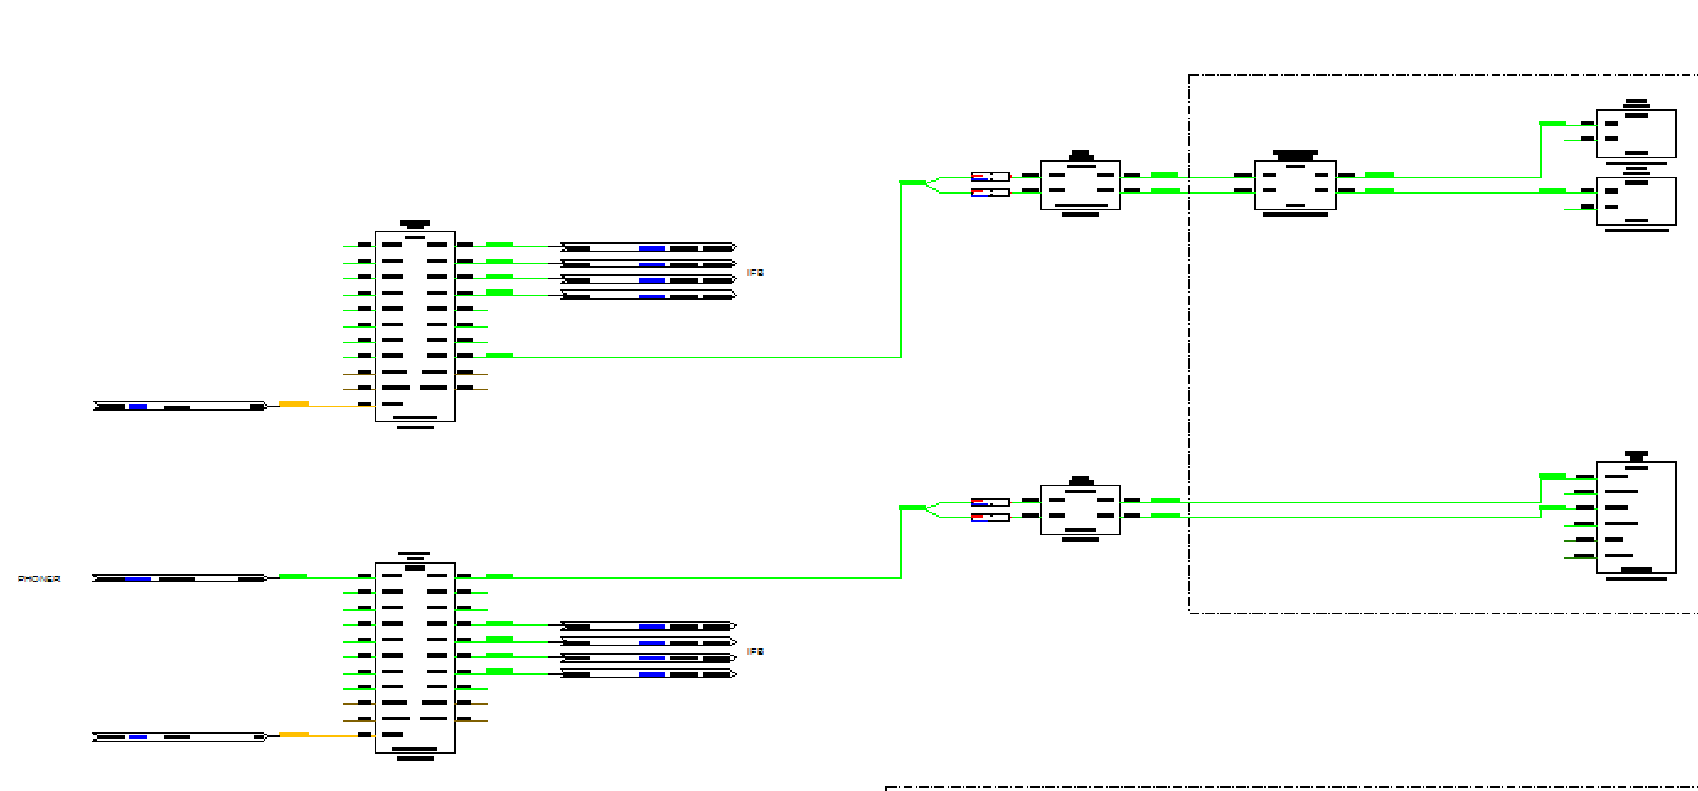
Do: include explanatory text or pinout references for signals that don’t follow the conventions or have special requirements. Try to answer the questions before they are asked.
Do: try and centralize distributed systems like facility routers, reference distribution and network switches.
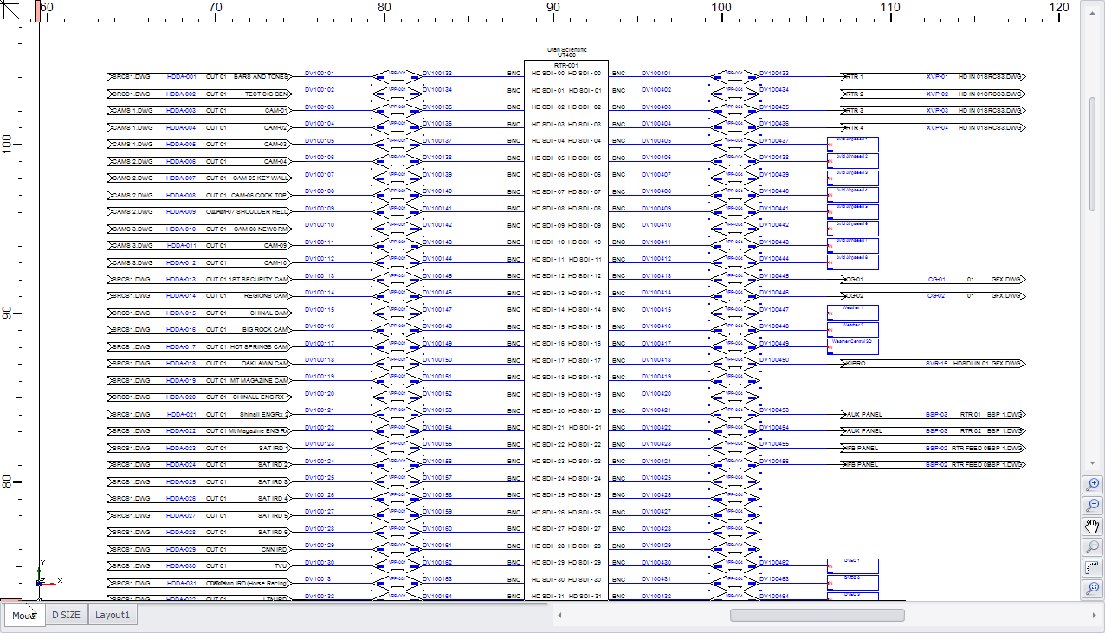
Do: be mindful of operator comfort when creating rack layouts.
Do: create rack layouts that include a separate location for the rear of any rack to which you are mounting equipment on the rear rails.
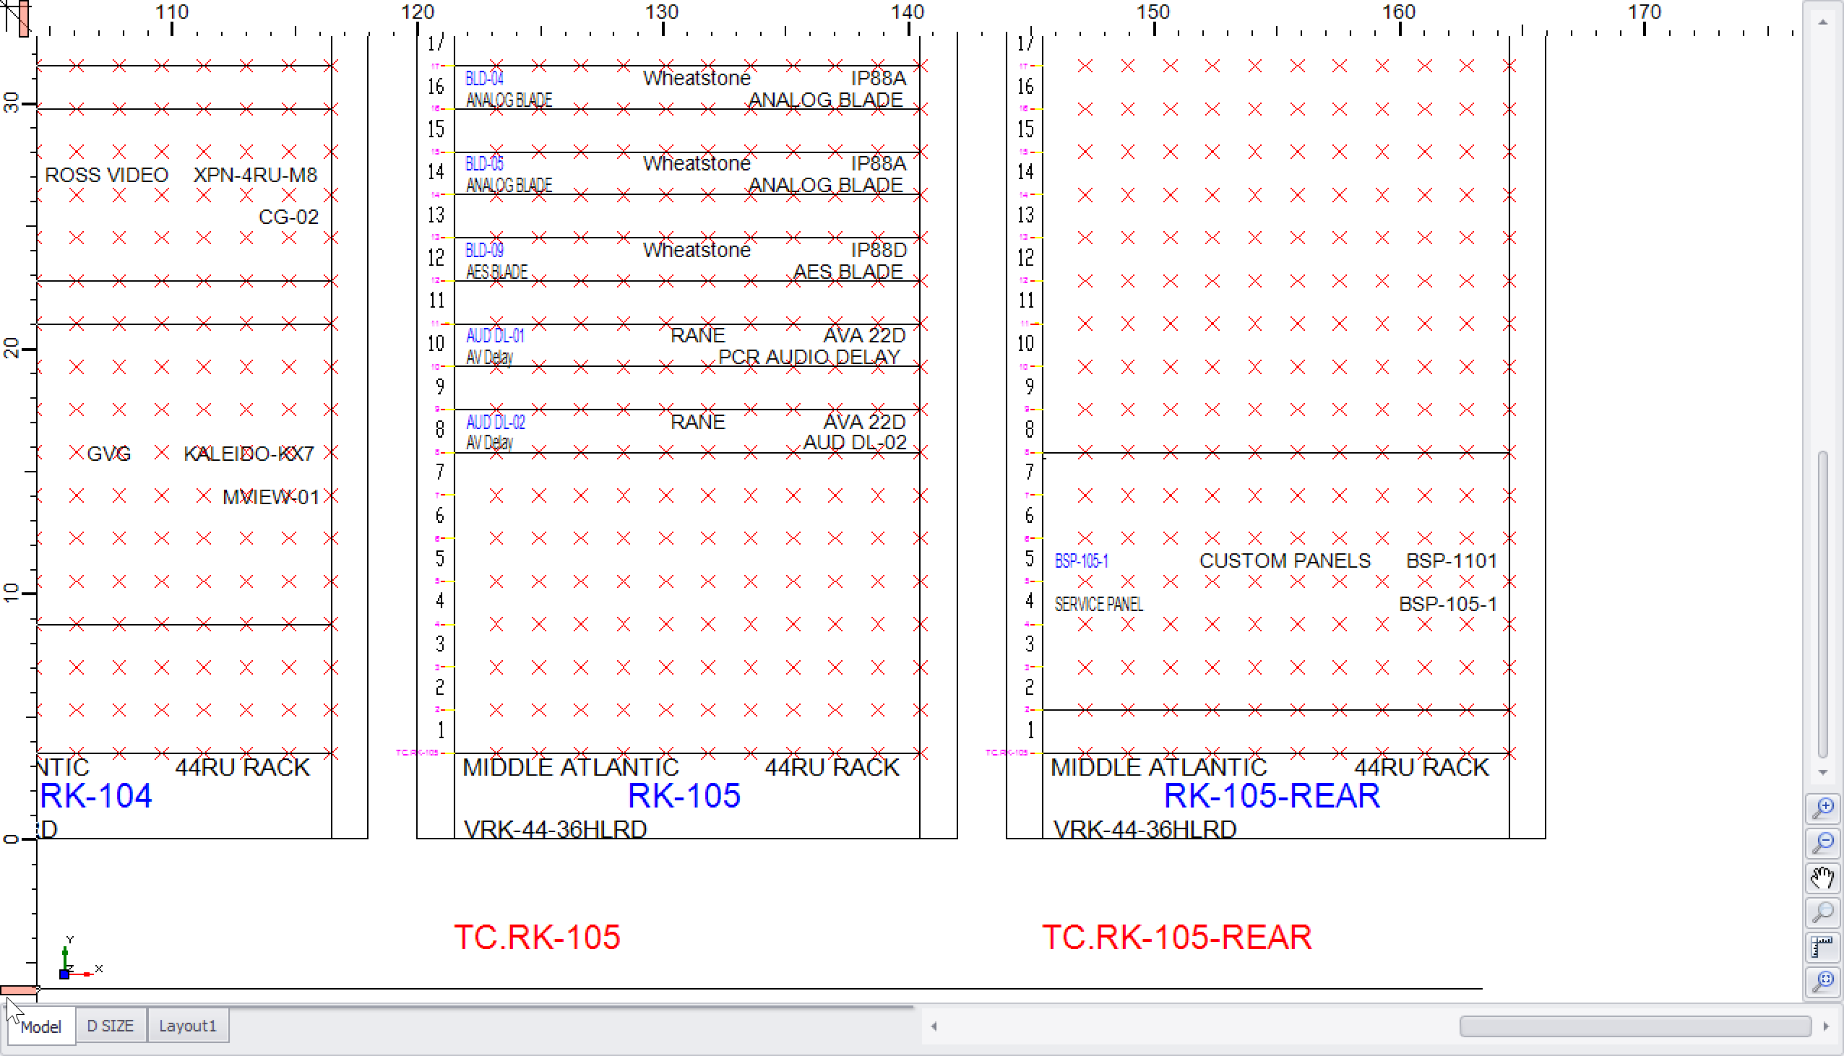

Don’t: Make pasta.
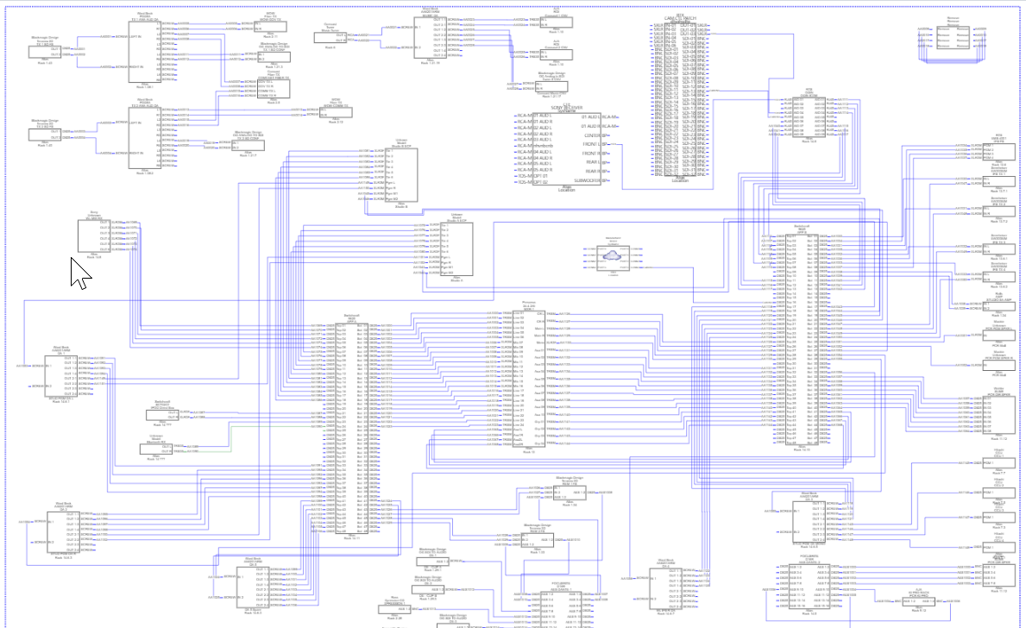

This drawing, while it contains everything it needs to convey the idea is difficult to read for several reasons:
- It does not follow the left-to-right rule.
- The block sizes are inconsistent.
- All the cables are the same color.
- There are no geographical markings that delineate different areas.

